

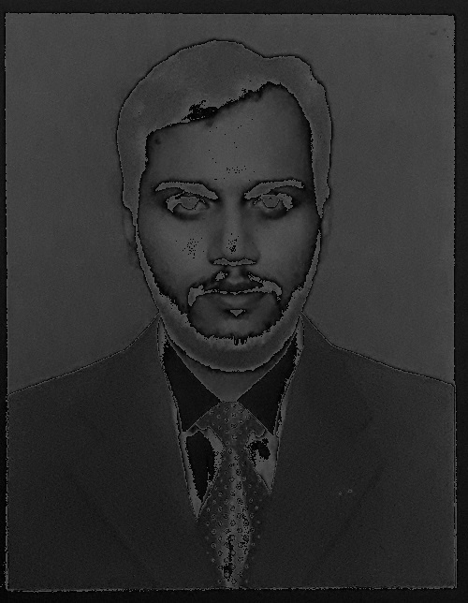

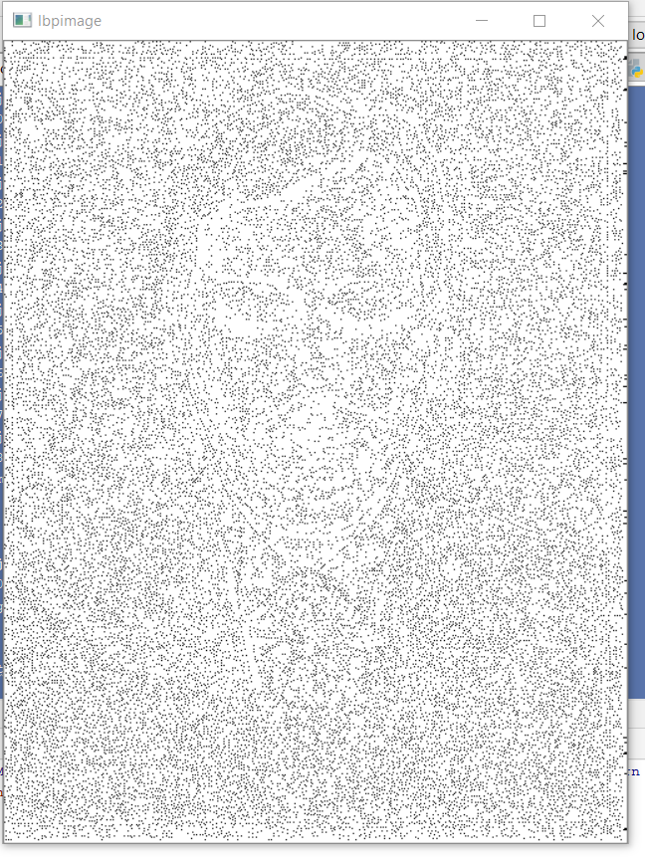

Coding:-
import cv2
import numpy as np
class A:
def __init__(self):
self.a=[0 for i in range(8)]
def lbp(self,image,x,y,p,r):
a, b, c, d, e = 0, 0, 0, 0, 0
help = [[A() for i in range(x)] for daa in range(y)]
neutral = image
neutralone = neutral
histogram = [0 for i in range(60)]
filter = [[0 for i in range(3)] for j in range(3)]
binarray = [[0 for i in range(3)] for j in range(3)]
canvas = np.zeros((644, 500, 3))
for i in range(x):
for j in range(y):
a = neutralone[i][j][0]
b = neutralone[i][j][1]
c = neutralone[i][j][2]
d = a + b + c
e = d // 3
neutralone[i][j][0] = e
neutralone[i][j][1] = e
neutralone[i][j][2] = e
cv2.imshow("gray image", neutralone)
cv2.imwrite("neutralfaceone.jpg", neutralone)
sum = 0
for i in range(644):
for j in range(500):
if (not (i > x-3)) and (not (j > y-3)):
filter[0][0] = neutralone[i][j][0]
filter[0][1] = neutralone[i][j + 1][0]
filter[0][2] = neutralone[i][j + 2][0]
filter[1][0] = neutralone[i + 1][j][0]
filter[1][1] = neutralone[i + 1][j + 1][0]
filter[1][2] = neutralone[i + 1][j + 2][0]
filter[2][0] = neutralone[i + 2][j][0]
filter[2][1] = neutralone[i + 2][j + 1][0]
filter[2][2] = neutralone[i + 2][j + 2][0]
# //= == == == == == == == == == == == == == == == == == == == == == ==
if filter[0][0] < filter[1][1]:
filter[0][0] = 0
else:
filter[0][0] = 1
# // -----------------------------
if filter[0][1] < filter[1][1]:
filter[0][1] = 0
else:
filter[0][1] = 1
# // -------------------------------
if filter[0][2] < filter[1][1]:
filter[0][2] = 0
else:
filter[0][2] = 1
# //= == == == == == == == == == == == == == ==
if filter[1][0] < filter[1][1]:
filter[1][0] = 0
else:
filter[1][0] = 1
# // ------------------------------------
# // missing
# because
# importance
# //= == == == == == == == == == == == == == == == == == == ==
if filter[1][2] < filter[1][1]:
filter[1][2] = 0
else:
filter[1][2] = 1
# //= == == == == == == == == == == == == == == == == == == == == =
if filter[1][2] < filter[1][1]:
filter[2][0] = 0
else:
filter[2][0] = 1
# //= == == == == == == == == == == == == =
if filter[2][1] < filter[1][1]:
filter[2][1] = 0
else:
filter[2][1] = 1
# //= == == == == == == == == == == == == == == ==
if filter[2][2] < filter[1][1]:
filter[2][2] = 0
else:
filter[2][2] = 1
# //= == == == == == == == == == == == == == == == ==
binarray[0][0] = filter[1][2]
binarray[0][1] = filter[2][2]
binarray[0][2] = filter[2][1]
binarray[1][0] = filter[2][0]
binarray[1][1] = filter[1][0]
binarray[1][2] = filter[0][0]
binarray[2][0] = filter[0][1]
binarray[2][1] = filter[0][2]
sum = binarray[0][0] * (2 ^ 7) + binarray[0][1] * (2 ^ 6) + binarray[0][2] * (2 ^ 5) + binarray[1][
0] * (2 ^ 4) + binarray[1][1] * (2 ^ 3) + binarray[1][2] * (2 ^ 2) + binarray[2][0] * (2 ^ 1) + \
binarray[2][1] * (2 ^ 0)
# if not i > 1918 and not j> 982:
canvas[i][j][0] = int(sum)
canvas[i][j][1] = int(sum)
canvas[i][j][2] = int(sum)
cv2.imshow("lbpimage", canvas)
cv2.imwrite("lbbpimage.jpg", canvas)
cv2.waitKey()
return canvas
def lbph(self, canvas, grid_x, grid_y):
histogram = [0 for i in range(58)]
help = [[A() for i in range(grid_y)] for daa in range(grid_x)]
k=0
tired=0
counter=0
for i in range(grid_x):
for j in range(grid_y):
tired = canvas[i][j][0]
while(tired!=0):
rem = tired // 2
mod = tired % 2
help[i][j].a[k] = mod
k = k + 1
tired = rem
k=0
zq=0
vk=0
for i in range(grid_x):
for j in range(grid_y):
counter=0
vk=0
for z in range(8):
if help[i][j].a[vk]==help[i][j].a[z]:
print()
else:
vk=z
counter=counter+1
if counter>2:
histogram[57]=histogram[57]+1
if counter <2:
if canvas[i][j][0]==0:
histogram[0]=histogram[0]+1
elif canvas[i][j][0]==1:
histogram[1]=histogram[1
]+1
elif canvas[i][j][0]==2:
histogram[2]=histogram[2]+1
elif canvas[i][j][0]==3:
histogram[3]=histogram[3]+1
elif canvas[i][j][0]==4:
histogram[4]=histogram[4]+1
elif canvas[i][j][0]==6:
histogram[5]=histogram[5]+1
elif canvas[i][j][0]==7:
histogram[6]=histogram[6]+1
elif canvas[i][j][0]==8:
histogram[7]=histogram[7]+1
elif canvas[i][j][0]==12:
histogram[8]=histogram[8]+1
elif canvas[i][j][0]==14:
histogram[9]=histogram[9]+1
elif canvas[i][j][0] == 15:
histogram[10] = histogram[10] + 1
elif canvas[i][j][0] == 16:
histogram[11] = histogram[11] + 1
elif canvas[i][j][0]==24:
histogram[12]=histogram[12]+1
elif canvas[i][j][0] ==28:
histogram[13] = histogram[13] + 1
elif canvas[i][j][0]==30:
histogram[14]=histogram[14]+1
elif canvas[i][j][0]==31:
histogram[16]=histogram[16]+1
elif canvas[i][j][0]==32:
histogram[17]=histogram[17]+1
elif canvas[i][j][0]==48:
histogram[17]=histogram[17]+1
elif canvas[i][j][0]==56:
histogram[18]=histogram[18]+1
elif canvas[i][j][0]==60:
histogram[19]=histogram[19]+1
elif canvas[i][j][0]==62:
histogram[21]=histogram[21]+1
elif canvas[i][j][0]==63:
histogram[22]=histogram[22]+1
elif canvas[i][j][0]==64:
histogram[23]=histogram[23]+1
elif canvas[i][j][0]==96:
histogram[23]=histogram[23]+1
elif canvas[i][j][0]==112:
histogram[24]=histogram[24]+1
elif canvas[i][j][0]==120:
histogram[25]=histogram[25]+1
elif canvas[i][j][0]==124:
histogram[26]=histogram[26]+1
elif canvas[i][j][0]==127:
histogram[27]=histogram[27]+1
elif canvas[i][j][0]==128:
histogram[28]=histogram[28]+1
elif canvas[i][j][0]==129:
histogram[29]=histogram[29]+1
elif canvas[i][j][0]==131:
histogram[30]=histogram[30]+1
elif canvas[i][j][0]==135:
histogram[31]=histogram[31]+1
elif canvas[i][j][0]==143:
histogram[32]=histogram[32]+1
elif canvas[i][j][0]==159:
histogram[33]=histogram[33]+159
elif canvas[i][j][0]==191:
histogram[34]=histogram[34]+1
elif canvas[i][j][0]==192:
histogram[35]=histogram[35]+1
elif canvas[i][j][0]==193:
histogram[36]=histogram[36]+1
elif canvas[i][j][0]==195:
histogram[37]=histogram[37]+1
elif canvas[i][j][0]==199:
histogram[38]=histogram[38]+1
elif canvas[i][j][0]==207:
histogram[39]=histogram[39]+1
elif canvas[i][j][0]==223:
histogram[40]=histogram[40]+1
elif canvas[i][j][0]==224:
histogram[41]=histogram[41]+1
elif canvas[i][j][0]==225:
histogram[42]=histogram[42]+1
elif canvas[i][j][0]==227:
histogram[43]=histogram[43]+1
elif canvas[i][j][0]==231:
histogram[44]=histogram[44]+1
elif canvas[i][j][0]==239:
histogram[45]=histogram[45]+1
elif canvas[i][j][0]==240:
histogram[46]=histogram[46]+1
elif canvas[i][j][0]==241:
histogram[47]=histogram[47]+1
elif canvas[i][j][0]==243:
histogram[48]=histogram[48]+1
elif canvas[i][j][0]==247:
histogram[49]=histogram[49]+1
elif canvas[i][j][0]==248:
histogram[50]=histogram[50]+1
elif canvas[i][j][0]==249:
histogram[51]=histogram[51]+1
elif canvas[i][j][0]==251:
histogram[52]=histogram[52]+1
elif canvas[i][j][0]==252:
histogram[53]=histogram[53]+1
elif canvas[i][j][0]==253:
histogram[54]=histogram[54]+1
elif canvas[i][j][0]==254:
histogram[55]=histogram[55]+1
elif canvas[i][j][0]==255:
histogram[56]=histogram[56]+1
return histogram
s1=A()
readimage=cv2.imread("mujtaba form.jpg")
lbpimageget=s1.lbp(readimage,644,500,8,1)
histogramofthisimage=s1.lbph(lbpimageget,644,500)

